Test Case: tc006_SPX_Dev5_Crear_Requisicion_Spot_Tipo_Cobro_Proyect_Urgent
Step 1 - Enter username and password and click to button Enter: Credentials Entered
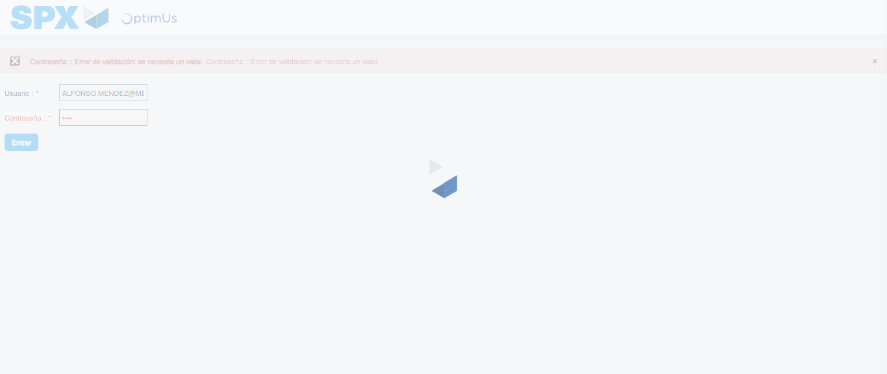Image file-name: QC_Testing-tc006_SPX_Dev5_Crear_Requisicion_Spot_Tipo_Cobro_Proyect_Urgent-1783362448647

Step 2 - Select to UEN and Access to Spot Buy Requisitions : UEN Correctly selected and Correct access
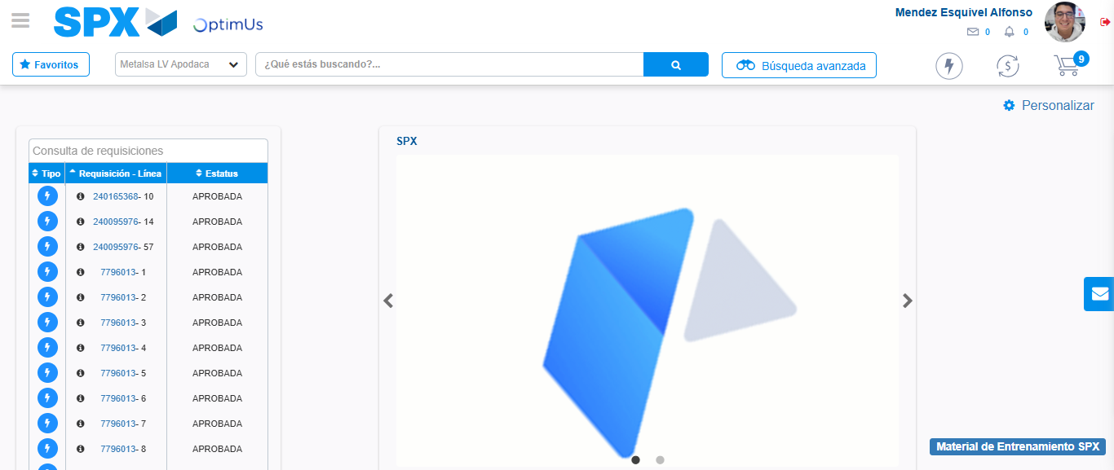Image file-name: QC_Testing-tc006_SPX_Dev5_Crear_Requisicion_Spot_Tipo_Cobro_Proyect_Urgent-1783362524110

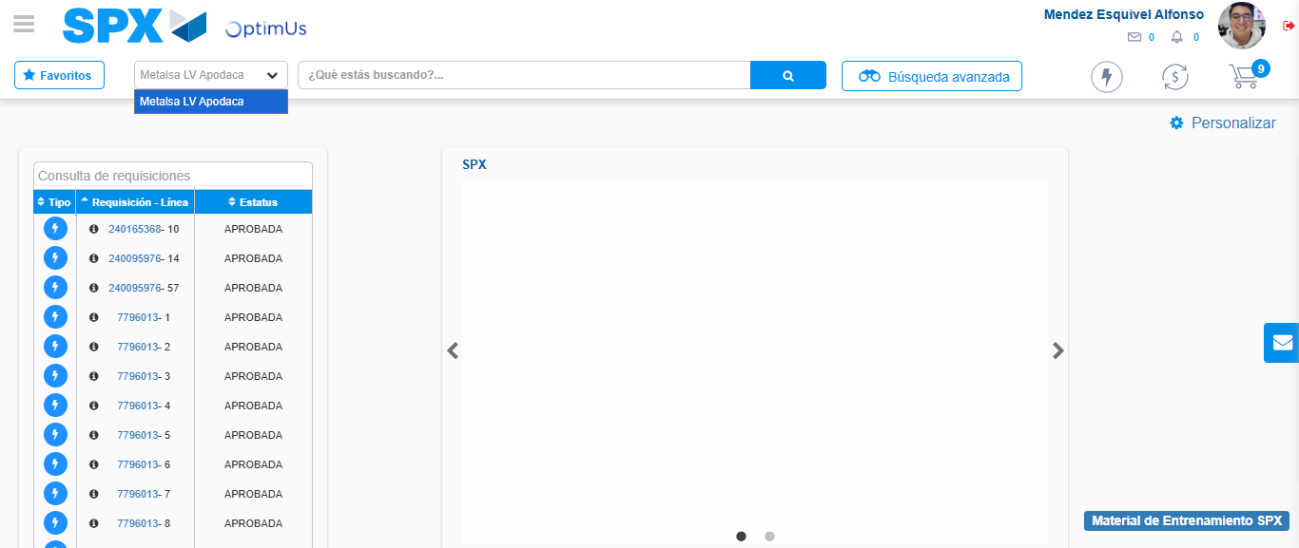Image file-name: QC_Testing-tc006_SPX_Dev5_Crear_Requisicion_Spot_Tipo_Cobro_Proyect_Urgent-1783362526609

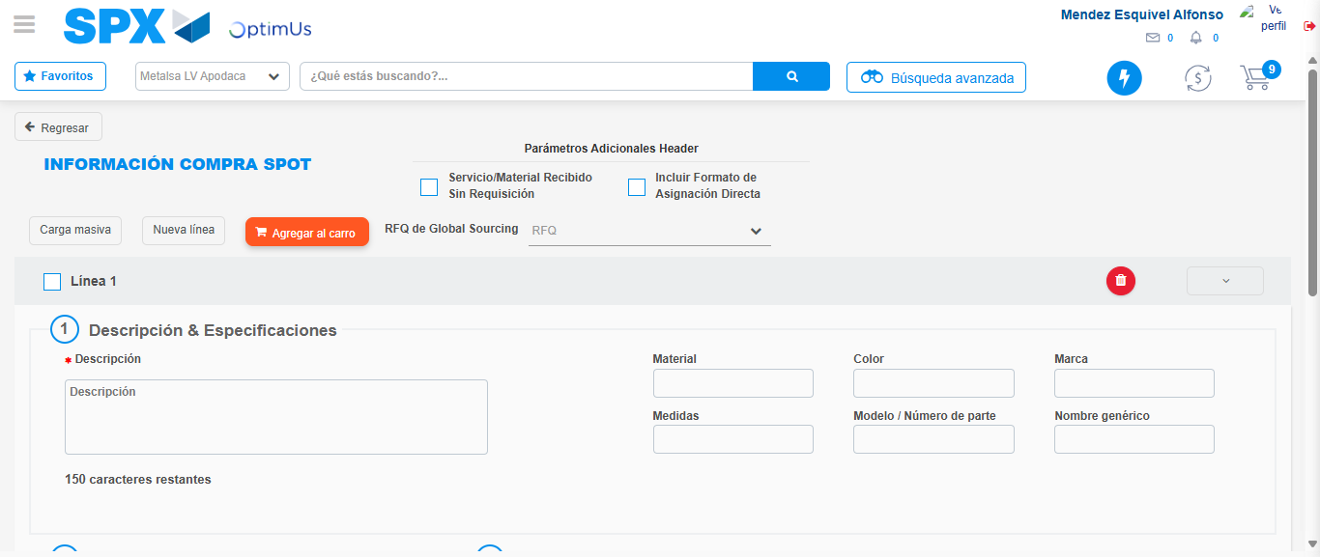Image file-name: QC_Testing-tc006_SPX_Dev5_Crear_Requisicion_Spot_Tipo_Cobro_Proyect_Urgent-1783362531811

Step 3 - Data Capture Spot Buy Requisition: Data captured correctly
Image file-name: QC_Testing-tc006_SPX_Dev5_Crear_Requisicion_Spot_Tipo_Cobro_Proyect_Urgent-1783362532036

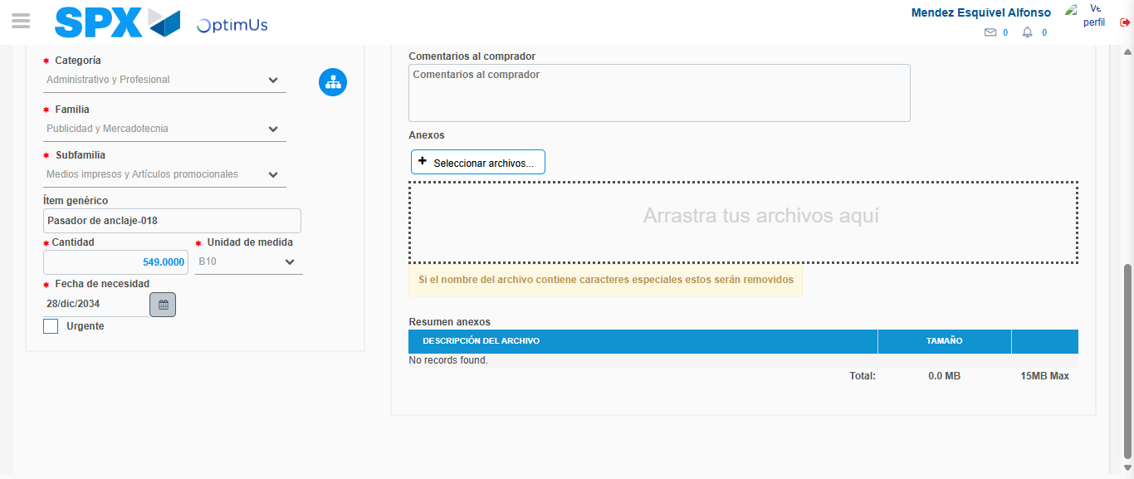Image file-name: QC_Testing-tc006_SPX_Dev5_Crear_Requisicion_Spot_Tipo_Cobro_Proyect_Urgent-1783362543123

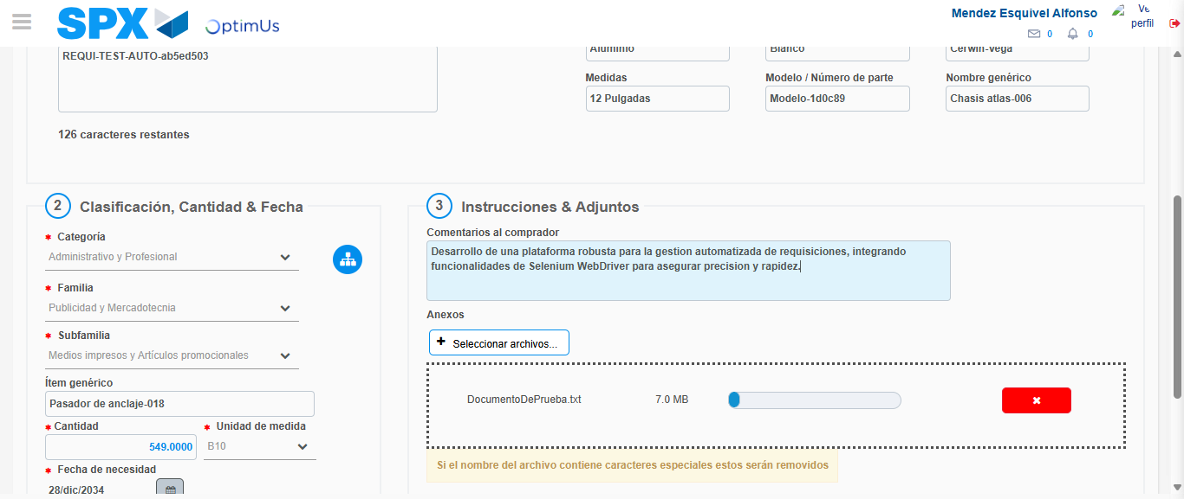Image file-name: QC_Testing-tc006_SPX_Dev5_Crear_Requisicion_Spot_Tipo_Cobro_Proyect_Urgent-1783362543887

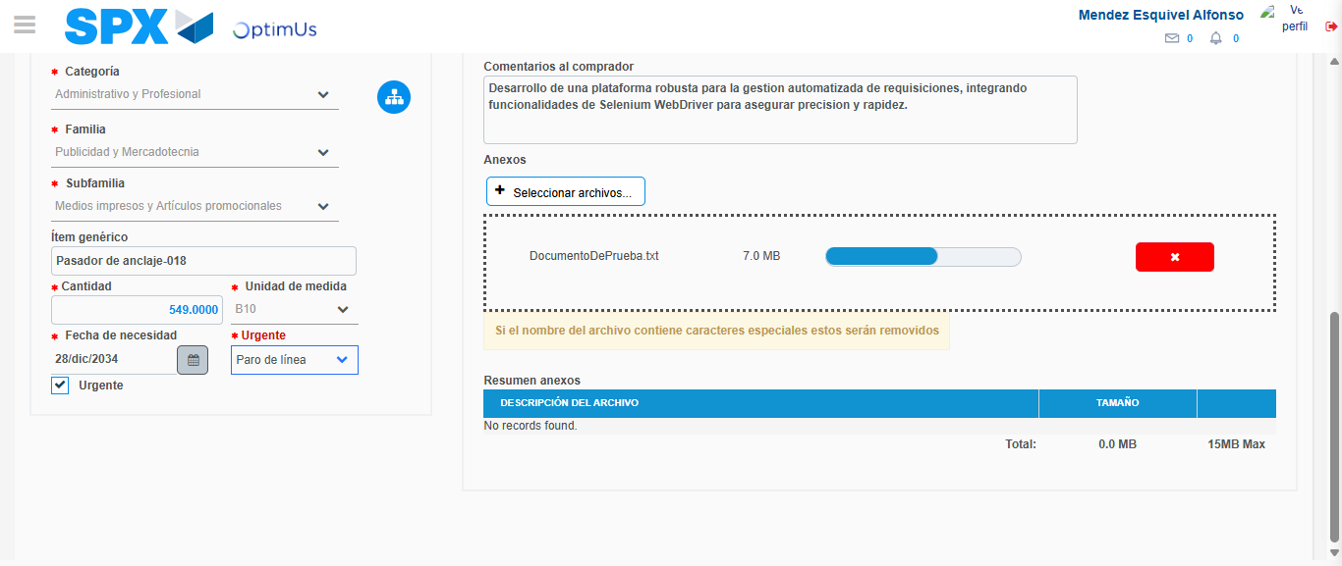Image file-name: QC_Testing-tc006_SPX_Dev5_Crear_Requisicion_Spot_Tipo_Cobro_Proyect_Urgent-1783362547557

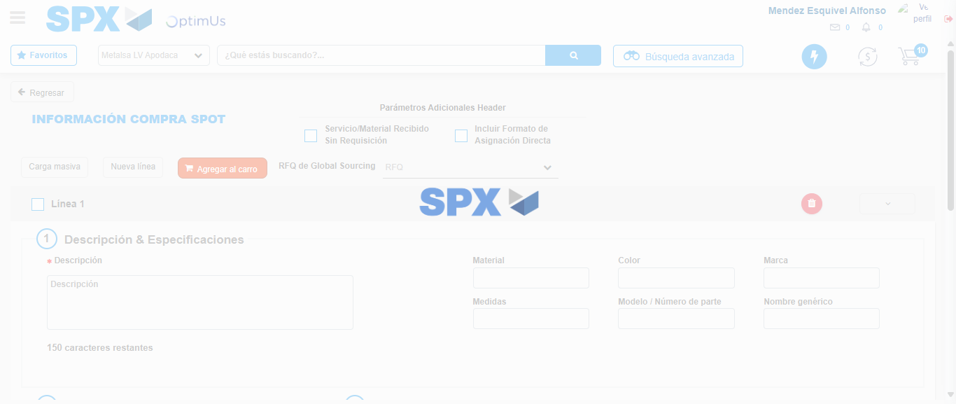Image file-name: QC_Testing-tc006_SPX_Dev5_Crear_Requisicion_Spot_Tipo_Cobro_Proyect_Urgent-1783362551464

Step 7 - Return to Main Page SPX : Return to Main Page SPX
Image file-name: QC_Testing-tc006_SPX_Dev5_Crear_Requisicion_Spot_Tipo_Cobro_Proyect_Urgent-1783362524110

Image file-name: QC_Testing-tc006_SPX_Dev5_Crear_Requisicion_Spot_Tipo_Cobro_Proyect_Urgent-1783362526609

Image file-name: QC_Testing-tc006_SPX_Dev5_Crear_Requisicion_Spot_Tipo_Cobro_Proyect_Urgent-1783362531811

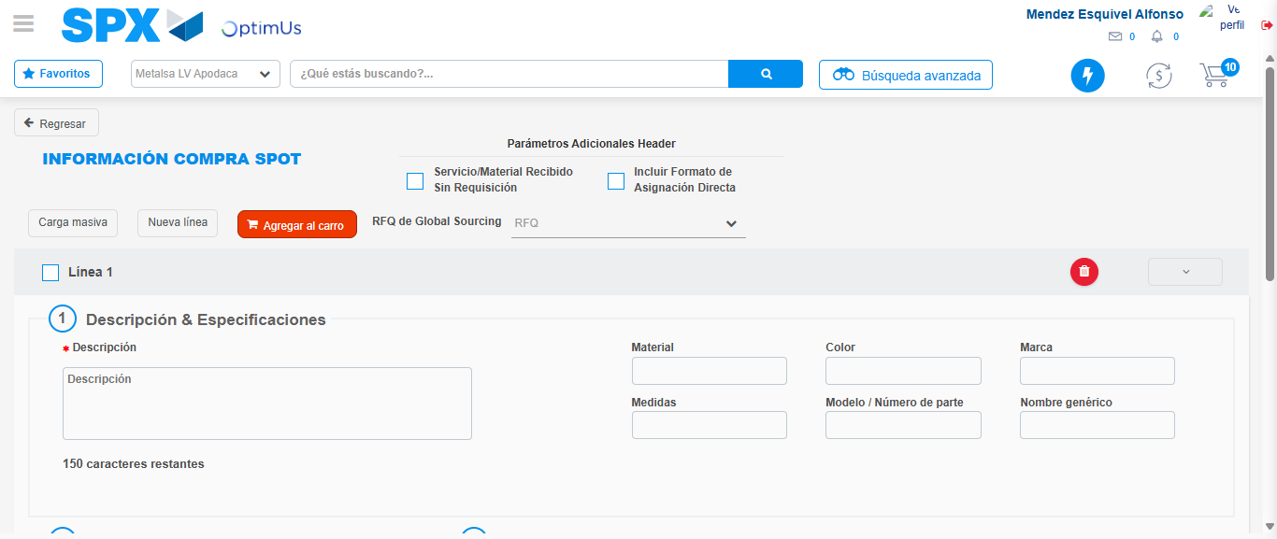Image file-name: QC_Testing-tc006_SPX_Dev5_Crear_Requisicion_Spot_Tipo_Cobro_Proyect_Urgent-1783362553687

Image file-name: QC_Testing-tc006_SPX_Dev5_Crear_Requisicion_Spot_Tipo_Cobro_Proyect_Urgent-1783362553856

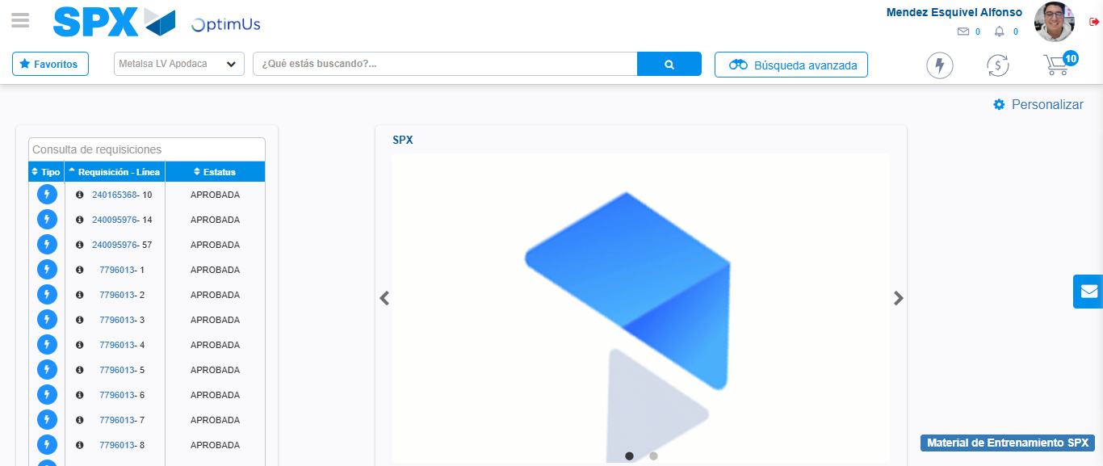Image file-name: QC_Testing-tc006_SPX_Dev5_Crear_Requisicion_Spot_Tipo_Cobro_Proyect_Urgent-1783362574891

Step 8 - Log Out : Log Out SPX
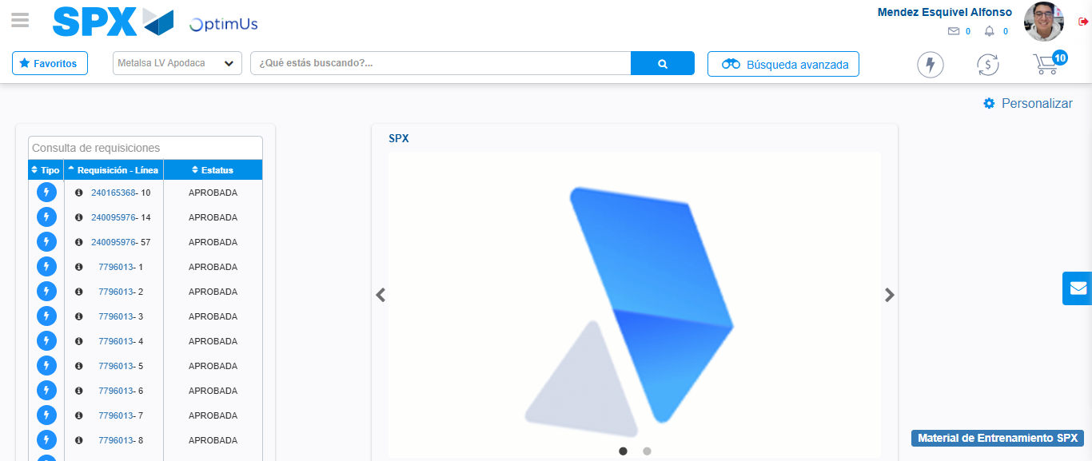Image file-name: QC_Testing-tc006_SPX_Dev5_Crear_Requisicion_Spot_Tipo_Cobro_Proyect_Urgent-1783362575120

